# Project Activity 5 – Final Presentation of your App

Describe your team's application:

1. Which requirements did you and your team achieve in implementation?

We achieved all the necessary requirements and goals that were planned. We created the website, implemented SQL injection, did database manipulation, and successfully defended against it. We also implemented automated testing with Jenkins. Sent our code to AWS servers and got it up there.

1. What development and testing tools did you use?

We used the php, css programming language to create the frontend. We used Brackets to edit the code. Then to raise the database we used MySQL language, for the local server we used XAMPP software.

PHPunit a series of tests, running code snippets to automatically check the correctness of parts (modules) of the website.

We take our code from GitHub, then connect it to Jenkins using SSH-key. We then build our code and test it. After a successful attempt, it checks for changes to our code every 10 minutes, if Jenkins detects any changes, it does a deploy to the AWS cloud. As a result, our code is fully tested and interacts with the AWS cloud.

Record your algorithm, input and expected results

|  |  |
| --- | --- |
| **Input** | **Result** |
| **PHP and CSS code** | **Frontend of Website** |
| **MySQL database** | **Backend of Website** |
| **Connect Frontend and Backend** | **Finished Website (2 versions) vulnerable and secured** |
| **PHPunit test** | **Checked the website of all code fragments with PHPunit test.** |
| **Jenkins test using SSH-key** | **Passed through Jenkins testing for code changes.** |

Strategy/Project Plan

Provide a brief description of your common team’s strategy for completing this project.

Upon completion of the project, our chosen strategy worked well and we met all requirements and goals, our strategy was to meet deadlines and budgets by dividing responsibilities amongst ourselves.

## Final Deliverables

### Presentation

Provide the following evidence (which will also be part of your presentation):

* Application code
* CI/CD jobs used
* Example output of running code showing:
  + Input data before test
  + Expected result after test
  + Status in CI/CD tool

Это наш код pipeline, который делает PHPunit тест, он проверяет каждые 10 минут на наличие изменений, и далее автоматически делает deploy на наш AWS сервер.

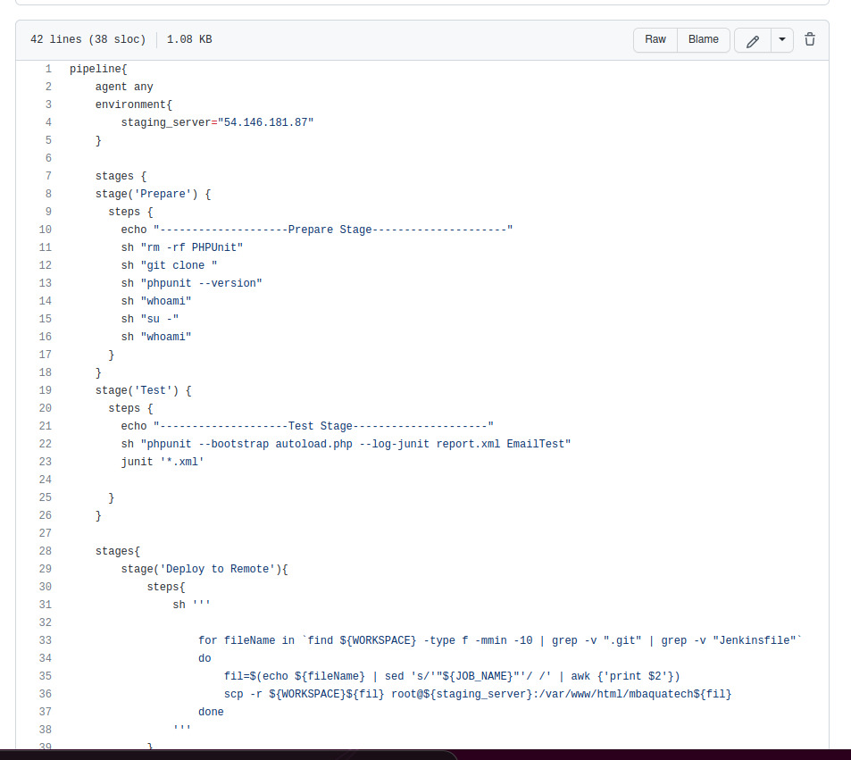

К примеру, мы тут сделали PHPunit тест на “welcome.php”, чтобы наглядно продемонстрировать логику тестирования.

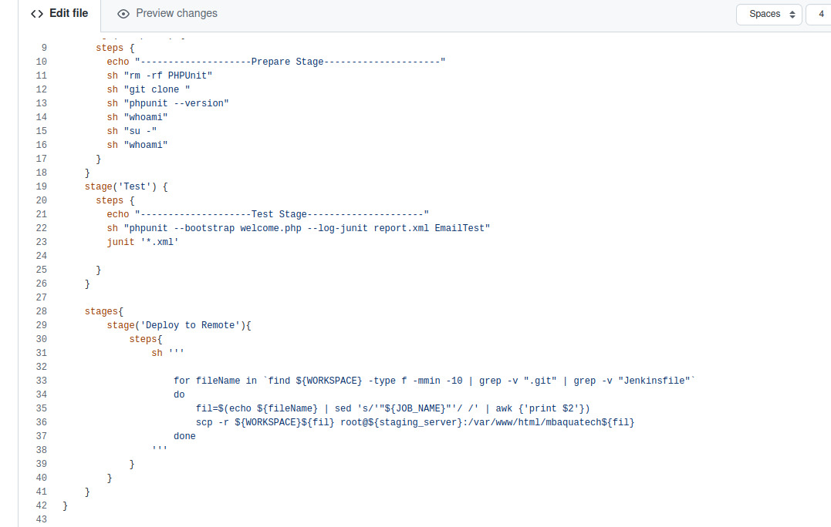

Скрипт pipeline с Jenkins, который делает deploy на удаленный сервер AWS.

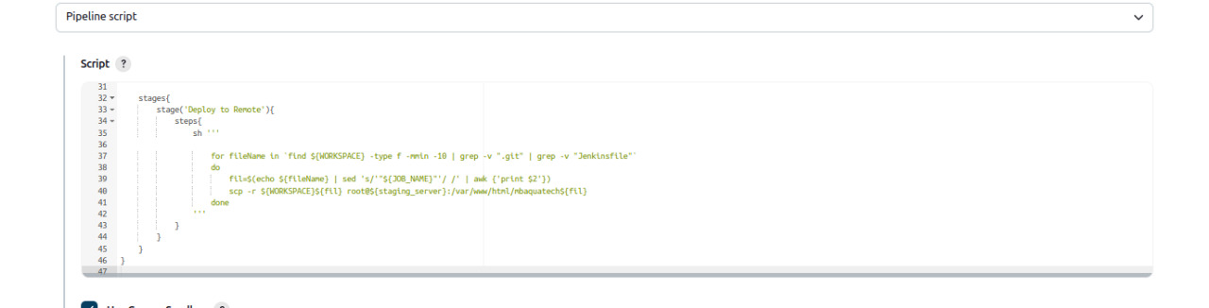

Как мы видим, наш скрипт pipeline, разделяется на stages, чтобы провести тестирование. И также указывается наш сервер AWS, его IP-адрес: 54.146.181.87

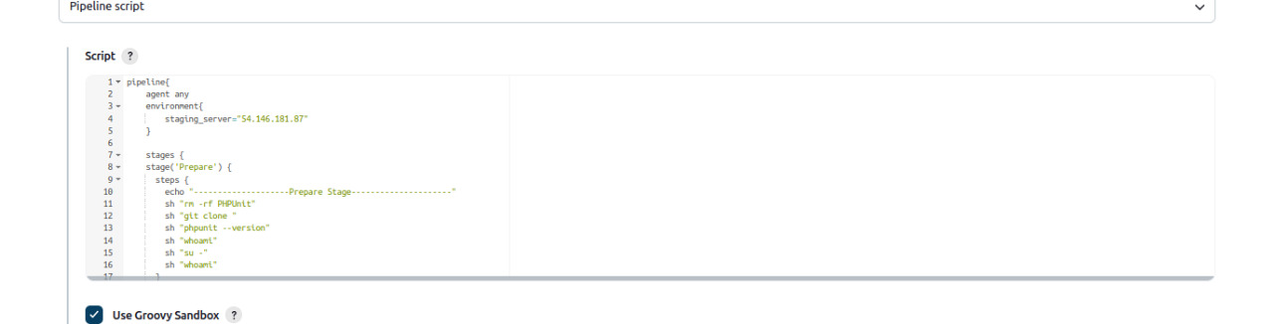

Тут показано как мы соединили GitHub и наш Jenkins, с помощью которого мы и делали наши тесты.

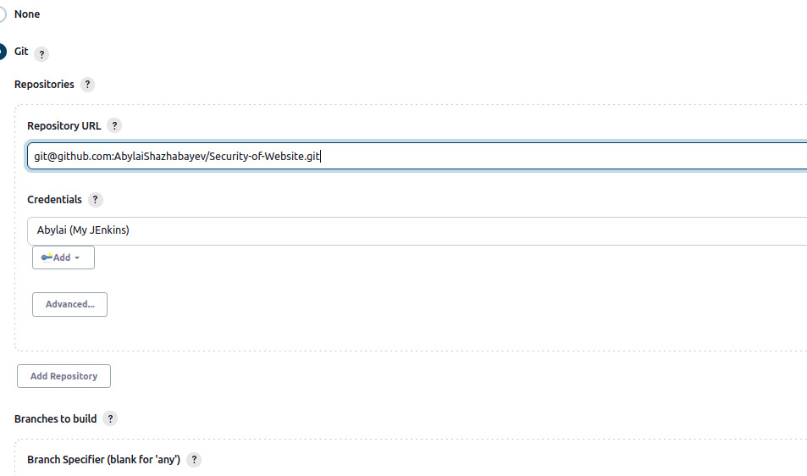

Здесь мы с помощью SSH-key соединили Jenkins с сервером AWS.

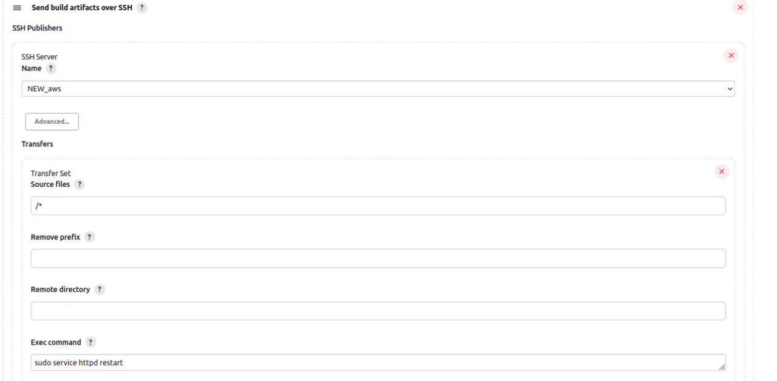

Это наша картина итоговых результатов проведенных тестирований, как мы можем видеть по build history, все последние тестирования горят зелеными индикаторами, что в свою очередь показывает, что все тестирования были успешны

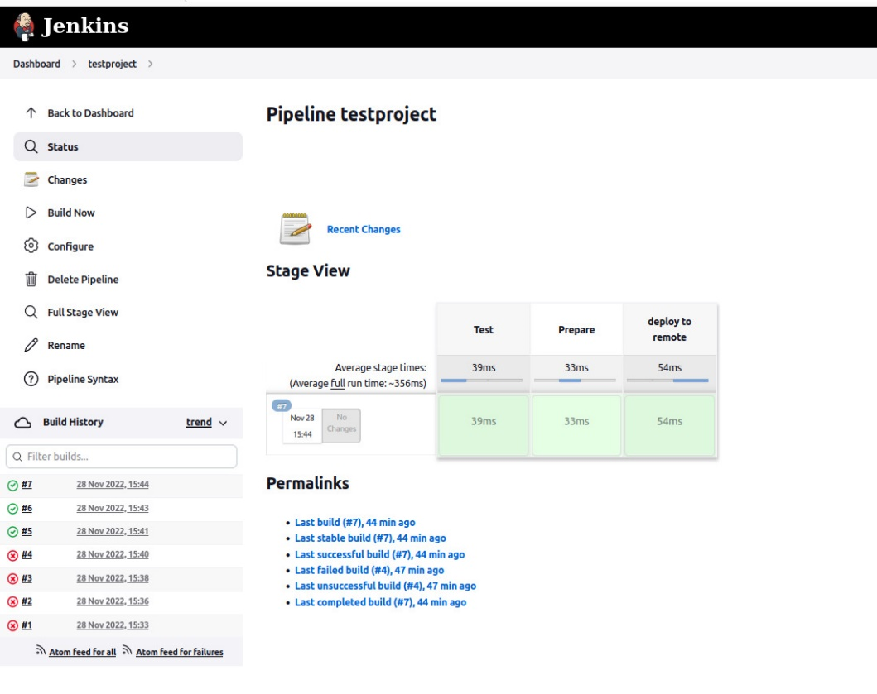

Reflect on the type of issues you have faced while working on this project. How did you find solutions and what have you learned?

**No special problems arose during the work, but even if they did, the project manager would have solved them quickly.**

**Team activities and reflection**

Deliverable/Rubric: Your manager is interested in knowing how everyone worked together as a team. Please do not forget to provide your evidence of team collaboration on GitHub or similar system version tool.

Below is a list of additional questions from your manager:

1. What did you enjoy about working as a team? What worked well?

**I liked the fact that everyone on the team shared their commitments and meticulously carried them out. When you divide a big task into smaller parts, it's easier to do it. It was the same with us, we divided the responsibilities between us, and everyone did what was required of him, and the result was a weighty project.**

1. What team problems did you encounter and how did you resolve them?

**No problems arose**

1. What technical problems did you encounter and how did you resolve them?

**There was a problem with XAMPP, where the MySQL server crashed, solved by replacing the wrong files with new ones by creating a new directory in the local MySQL directory.**

**Amazon banned our account because we had created many servers on their platform and had to pay 10 dollars to unbanned them.**

1. How was each team member held accountable individually and for the team as a whole?

**We communicated through teams, where everyone demonstrated their part of the project, and through GitHub we interacted with our branches.**

1. What was your team's decision-making process?

**The project manager Yerdos was responsible for the decision-making process, there were also general meetings to clarify situations.**

1. Overall, how were the team dynamics and what were any lessons learned?

**The dynamics of the team was intense, the tasks were not easy, and they were solved, we learned the lessons that we need more interaction as a team.**